Self-Declaration of UL Certification Compliance

April 9th, 2025

To Whom It May Concern:

We hereby declare the following models:
Model A423 and Model Z75
have been manufactured following the applicable design specifications and are identical in construction and materials to the samples previously submitted to UL for testing and evaluation.
All components, materials, and manufacturing processes used in these models are consistent with those reviewed and approved by Underwriters Laboratories (UL). No changes have been made that would affect the compliance of these models with the relevant UL standards.
These models continue to meet all requirements and safety standards as defined in the UL certification guidelines. Additional certification and registration details can be verified on UL’s official Product iQ database at:
https://productiq.ulprospector.com/en/profile/2858163/azot.e472647?term=ACTi&page=1
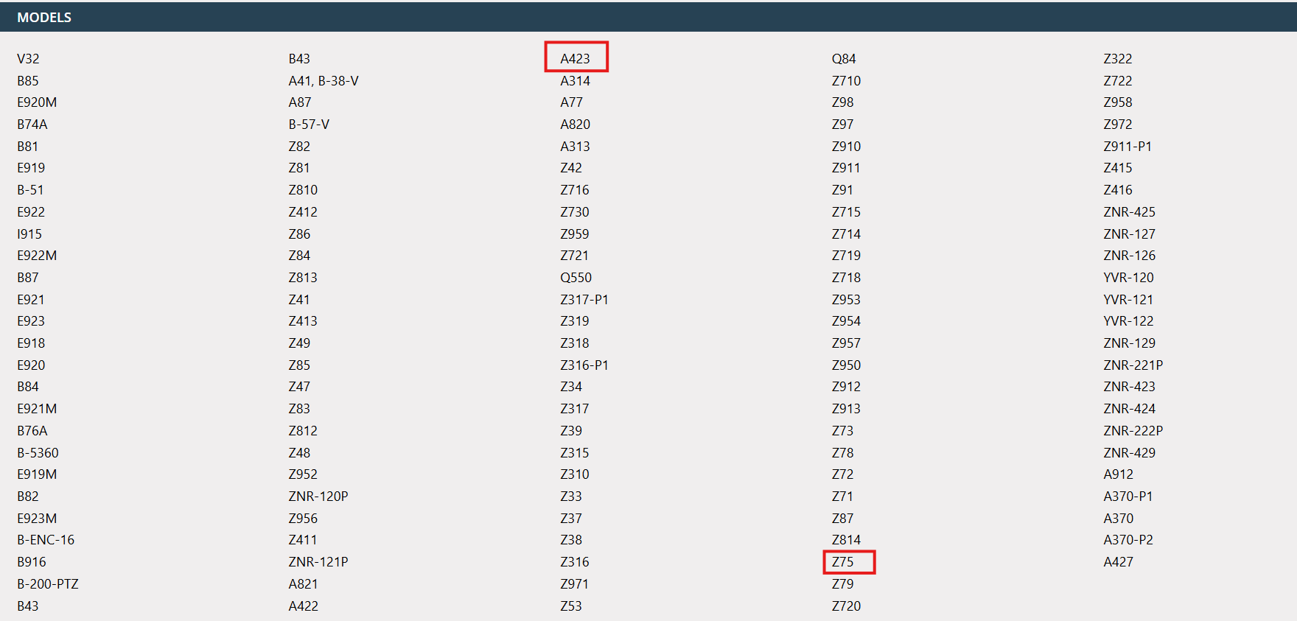

If you require any further information or documentation, please feel free to contact us.

Regards,
Vera Tai
Sales Account Manager

ACTi Corporation.


